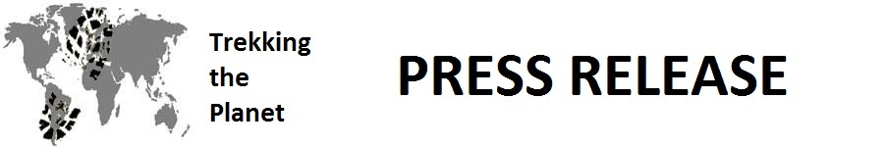

FOR IMMEDIATE RELEASE
ATTN: EDUCATION REPORTERS AND EDITORS
Contact: Chuck Van Soye
January 28, 2012 (714) 323-4111
Chuck@trekkingtheplanet.net

“REALITY” TO BOOST 21ST CENTURY EDUCATION

Blend of reality world travel plus technology
will make geography come alive in classrooms.

Key West, FL – Tweets from Cairo’s street rebellion, an unknown singer’s dramatic debut on YouTube, or the latest TV episode from “American Idol” have all captivated America’s young people. Every day, reality brings something new and exciting for them to vicariously share. Why not use reality to teach geography, to make it come alive in all its fullness? Trekking the Planet is providing 60 weeks of on-the-spot around-the-world travel materials, to be accessed FREE by participating school classrooms.

On January 28th, 2012, two Trekking the Planet travelers embarked on a 424-day expedition to explore the cities, peoples, history, economics, topography, nature and customs of 50 countries on six continents, along with treks into 12 of the world’s most remote and unspoiled places of natural or cultural significance. The travelers will also focus on the environment and on sustainability practices, highlighting where the world is being threatened or improved. The mission of this non-profit venture will be to provide materials while en route to help schools all over the world to better educate students about human and physical geography in new and exciting ways.

Teachers are able to access each of the 60 weekly four-page modules online as supplements to geography teaching already being taught. Trekking the Planet will also provide emails, photography, interviews, audio and video while traveling around the world. Maps and coordinates will highlight these locations. Students can formulate and post questions on Facebook and Twitter to be answered by the travelers in the subsequent week’s materials. Teachers may find the information provided as useful reference material for student use in assigned reports or student-created media incorporating pictures or video. Any educator may enroll to participate at http://www.TrekkingthePlanet.net/educators.

Studies show that American knowledge of geography is one of the worst in the world. In one study, US young adults finished eighth out of nine countries, and 29% could not locate the Pacific Ocean on a map.
Trekking the Planet hopes to help our educators change these statistics for future generations.
end
___________________________________________________________________________________
For greater detail about this expedition, reporters and editors are invited to access the following: websites – http://www.TrekkingthePlanet.net http://www.TrekkingthePlanet.net/about-us

