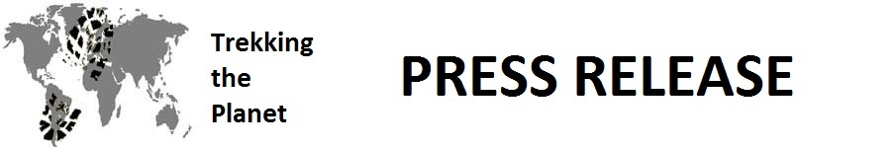

FOR IMMEDIATE RELEASE
ATTN: EDUCATION REPORTERS AND EDITORS
Contact: Chuck Van Soye
December 14, 2012 (714) 323-4111
Chuck@trekkingtheplanet.net

California Couple Pass 50,000 Mile Mark as they Trek the Planet

The Trekking the Planet expedition uses travel as a way to get kids excited about geography. Eight hundred fifty classrooms in 20 countries have subscribed to their educational materials.

Key West, FL – On January 28, 2012, two Trekking the Planet travelers embarked on a 424-day expedition to explore the cities, peoples, history, economics, topography, nature and customs of 50 plus countries on six continents. The mission of the Trekking the Planet expedition is to get students excited about geography by exposing them to interactive and highly-visual educational materials. To date, they have traveled to 40 countries with another 13 or so to go before they return to the United Sates. Eight hundred fifty classrooms in 20 countries, representing 55,000 students, are following their journey over the Internet.

Darren and Sandy Van Soye have reached the island of Madeira, Portugal, aboard the Pacific Princess en route to Manaus, Brazil, which is located 600 miles up the Amazon River. Their arrival in Madeira puts their total distance traveled at 20,000 miles by ship and over the 50,000 miles total – or the equivalent of more than twice around the world. Over the past two months, Darren and Sandy visited Africa and the Middle East. They took a three-day walking safari just outside the Maasai Mara National Reserve in Kenya. They trekked in the Simien Mountains in Ethiopia. And, they hiked along Bedouin trails to the archeological gem of Petra in Jordan. In Kenya and Ethiopia, they had the opportunity to visit schools. The couple has documented these school visits on their website. The Live Tracker page shows their current location.

Teachers have access to a growing library of four-page education modules available as supplements to existing classroom materials. In addition, Trekking the Planet provides articles, weekly quizzes and videos all free of charge to educators. Students continue to formulate and post questions on Twitter and Facebook or by email and are answered by the travelers in near real-time, making this an unprecedented interactive venture. Educators can enroll on the Educators page. Armchair travelers can also receive the couple’s updates by subscribing on the Friends page.

Studies show that American knowledge of geography is one of the worst in the world. In one study, US young adults finished eighth out of nine countries, and, in another study, 29% could not locate the Pacific Ocean on a map. Trekking the Planet hopes to help educators change these statistics for future generations.

***End***
___________________________________________________________________________________
For further details about this expedition, reporters and editors are invited to access the Trekking the Planet press page – http://www.trekkingtheplanet.net/pressroom

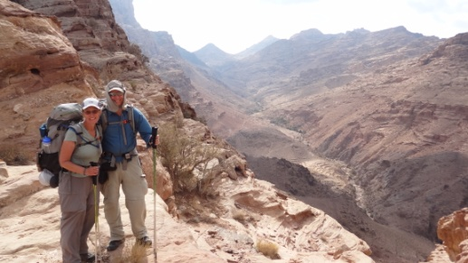  Darren and Sandy Van Soye on an Old Bedouin Trail Two Days Away From Petra in Jordan | 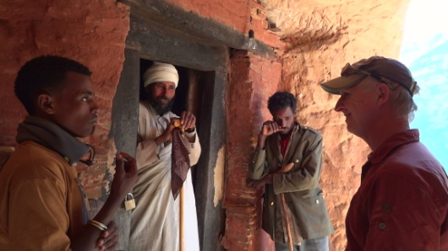  Darren Van Soye Interviewing Monk in Tigray Region of Northern Ethiopia | 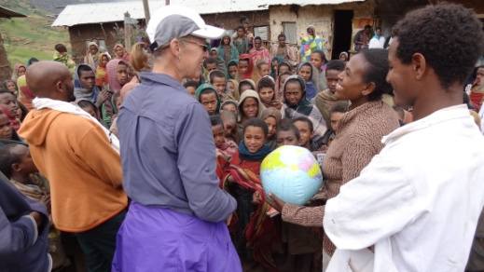  Sandy Van Soye gives gift of inflatable globe to head teacher at Argin Jona School, located in the Simien Mountains in Ethiopia

